‘Gardener’s World’
Summer 1 & 2
English
My Magic Spring Box
Poetry
Sunflower Seed Packet
Instructions, bossy verbs
Toys in Space
Sentences, suffixes, prefixes, stories
Minibeast Riddles
Pronoun I, adjectives
Goldilocks and Just the One Bear
Sentences, question mark, Non-fictional
writing
Seaside Poetry

Capital Letters, finger spaces, question marks, exclamation marks and full stops
Using ‘and’ to join sentences
Numeracy
Number, addition and subtraction:
1.9 Composition of numbers: 20-100
- Counting by making groups of ten
- Place value on a number line
- Tens and ones
1.10 Composition of numbers: 11-19
- Addition and subtraction facts within 20
- Doubling and halving
2.1 Counting and Unitising coins
- Counting in 2,s, 5’s and 10’s
- Coin recognition
Division – sharing objects into equal groups
Time – telling the time to the hour and half hour
Geometry – mass – position and direction

Science
Plants
Growing a bean plant (what a plant needs)
Plant hunt
Parts of a plant
Plant life-cycle
Seasonal Changes
Spring and Summer
All Creatures Great and Small
Identifying different animals
Comparing and sorting mammals, birds,
reptiles, fish, amphibians
Finding out what animals eat
Looking after our pets

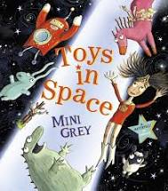
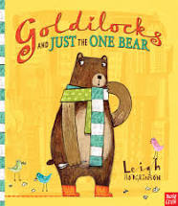
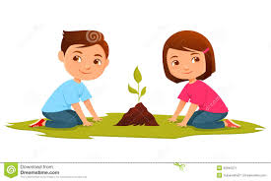
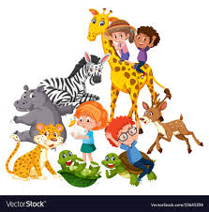

Computing
Programming A – Moving a robot
Children will explore using individual commands, both with other learners and as part of a computer program. Programming B – Introduction to animiation
Children will be introduced to on-screen programming through ScratchJr.

Art
Guiseppe Arcimboldo
Four Seasons and Four Elements
Portraits
3D models
Batik Flowers
Design and Make a batik flower
Use textiles to enhance design

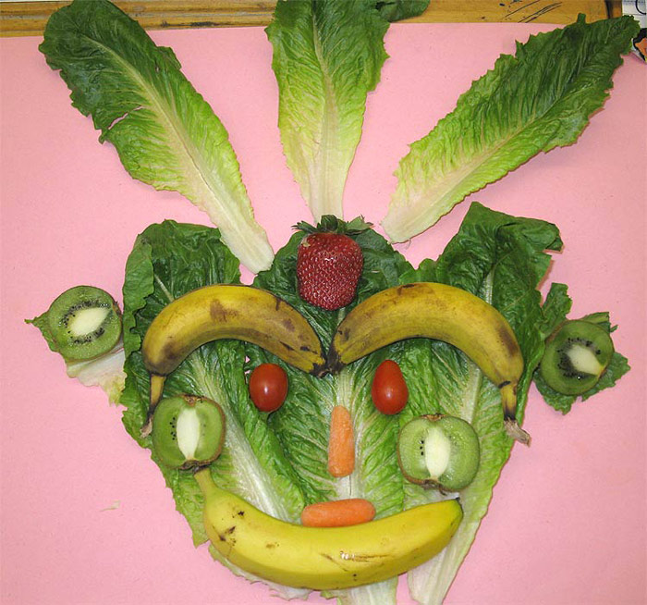

Year 1
RE
Gospel (1.4)
What is the ‘good news’ Christians believe Jesus brings?
Tell stories from the Bible and recognise a link with the concept of ‘Gospel’ or ‘Good News’.
Explore the themes of forgiveness, friendship and peace.
Caring for our World (1.9)
How should we care for the world and for others and for others, and why does it matter?
Identify a story or text that says something about each person being unique and valuable
Who is a disciple?
How do Christian and Jewish people believe that the world should be treated?
History
Seaside Holidays in the Past
Features of seaside holidays
How has the transport changed?
Use photographic evidence
Compare then and now
Geography
My Home Town
What is our local area like?
Fieldwork
Houses and Homes
Local jobs
Compare the Ludlow with a
seaside town.

PSCHE & SRE
Living in the wider world (Rights and Responsibilities; Taking Care of the Environment; Money Matters)
Care and Commitment
Hygeine
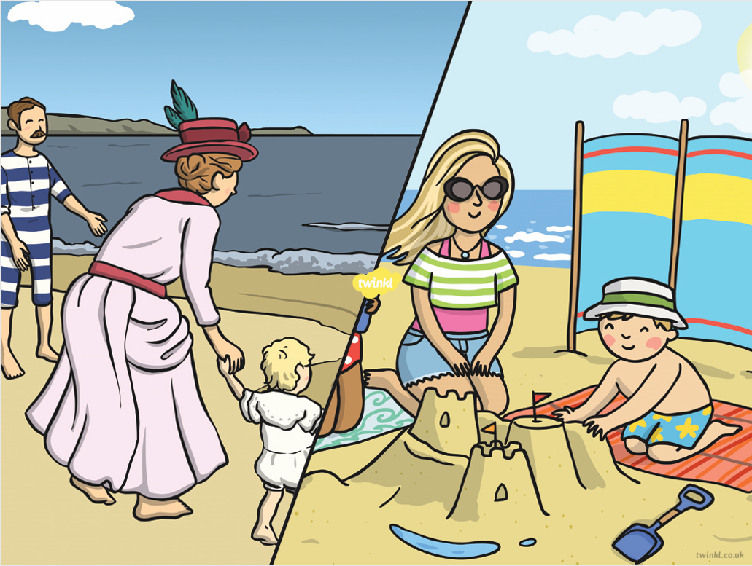
Music
Music Appreciation
‘What’s the Score?’ – recognise different ways sounds are made and changed and to name, and know how to play, a variety of classroom instruments.
‘Rain Rain go Away’ – recognise how sounds and instruments can be used expressively and combined to create music in response to a stimulus.
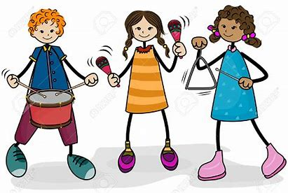

PE
Games
Invasion games
Multi-skills
Sports day skills

