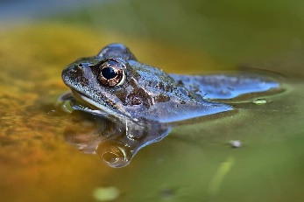
Class 5 Summer Term 2023

Dear Parents and Carers,
Welcome back to the Summer Term. Although the Pioneer Centre is now behind us, we
still have many exciting things to look forward to.
This half term, a large part of our work will centre around the natural world and how we impact upon it. We will learn about plant and animal life cycles in Science and our main book in English is also linked to this theme. In addition, we will be learning about World War II and some of the key events including The Battle of Britain and The Blitz. In D&T, we will find out about using seasonal produce to make a healthy and delicious soup and linking this to our work about ‘Land girls’ and rationing. If you have any family stories or objects linked to World War 2, then we would love to hear about them.
Mrs. Stevens will continue to teach on a Friday while Miss Martin and Mrs. Tengiz will support the children throughout the week.
Reading
This term, children will continue to bring home a school reading book and complete a quiz when they have completed it. Please sign your child’s diary to show that you have heard them read (or that they have read to themselves) at least three times a week.
Reading diaries must be in school every day.
please.
I am particularly excited to announce that children in KS2 will be having a virtual visit and workshop with the poet Brian Moses this term.
PE / Outside learning
As the weather improves and we regain the whole playground, we will be looking for opportunities to take our learning outside, where possible.
PE kits need to be in school all week, please.
We would politely remind you that children should have a school PE kit and for hygiene reasons, should not wear their usual school
T-shirt for PE.
The school PE kit:
- White or jade green T-shirt
- White or dark coloured shorts
(or joggers in cold weather)
- Pumps or Trainers

It is also useful if children have a spare pair of socks and a hair band for long hair.

Seesaw/ Homework
I will continue to set a weekly homework task on Seesaw. Please let me know if you need a new login code.
Homework will appear on Seesaw on a Tuesday, and it should be completed by the following Monday at the latest.
Please note that I will not look at Seesaw every day so I would be grateful if you could contact the school office with any important messages.

Pioneer Centre Residential Trip 2023
I am enormously proud of Year 5 for the excellent behaviour and cheerful outlook they showed towards all aspects of our residential visit. They showed courage, confidence and enthusiasm for all activities and it was a pleasure to take them.
When we return to our newly extended classroom, there will be a display of photos for you and your children to enjoy.

Spellings
The spelling test will take place on a Monday each week. New spellings will also be given out on this day so please make sure that your child keeps their yellow spelling book in their book bag.

Please do not hesitate to contact me if you have any questions or concerns about your child or our activities this term. Best Wishes,

Mrs. Mintoft

